Deploying Juniper MACSec with Configlet

AOS v3.3.0.2

Revised:  
Owners: Andy Ford

Status: Incomplete draft

# 

Background

Problem Statement

How to re-create this test

Adding an external router

View from DC1

View from DC2

P2P link IP addressing

View from DC1

View from DC2

Configuring MACsec Using CAK

To configure MACsec using static CAK security mode

Create a connectivity association

How to view MACSec working

How the configlets looks in AIS

# 

# 

# Background

Media Access Control Security (MACsec) is an industry-standard security technology that provides secure communication for almost all types of traffic on Ethernet links. MACsec provides point-to-point security on Ethernet links between directly-connected nodes and is capable of identifying and preventing most security threats, including denial of service, intrusion, man-in-the-middle, masquerading, passive wiretapping, and playback attacks. MACsec is standardized in IEEE 802.1AE.

You can configure MACsec to secure point-to-point Ethernet links connecting switches, or on Ethernet links connecting a switch to a host device such as a PC, phone, or server. Each point-to-point Ethernet link that you want to secure using MACsec must be configured independently. Two approaches to implementing MACSec

1. Static Secure Association Key (SAK) security mode
2. Static Connectivity Association Key (CAK)

CAK is the preferred method for switches, as described below.

|  |
| --- |
| [Juniper Best Practice Statement](https://www.juniper.net/documentation/en_US/junos/topics/task/configuration/macsec.html)  We recommend enabling MACsec using static CAK security mode on switch-to-switch links. Static CAK security mode ensures security by frequently refreshing to a new random secure association key (SAK) and by only sharing the SAK between the two devices on the MACsec-secured point-to-point link. Additionally, some optional MACsec features—replay protection, SCI tagging, and the ability to exclude traffic from MACsec—are only available in static CAK security mode. |

|  |
| --- |
| **Note:**  A feature license is required to configure MACsec on an EX Series or a QFX Series switch, with the exception of the QFX10000-6C-DWDM and QFX10000-30C-M line cards. If the MACsec licence is not installed, MACsec functionality cannot be activated.  The MACsec feature license is an independent feature license and not part of an enhanced or advanced feature license aka EFL / AFL |

# Problem Statement

P2P DCI links at Juniper are often secured with MACSec. With AOS v3.3.0.2, MACSec isn’t supported as part of the Intent model. This document describes how to deploy MACSec with a configlet.

# How to re-create this test

The config used in the configlet was built by using set commands on two QFX5120-48YM switches in a lab environment. In this lab, port et-0/0/48 on both switches, were connected together, to simulate the DCI connection.

Two Blueprints were created which consisted of an undeployed spine and the deployed QFX5120-48YM border leaf.

|  |  |
| --- | --- |
| AIS topology - view from DC2 | External Routers |
|  | * MACsec-DC1-BL   + 192.168.0.9   + 64521 * MACsec-DC2-BL   + 192.168.0.13   + 64523 |

## Adding an external router

In each BP, an external router was created on et-0/0/48 and the opposite BL added as an external router

### View from DC1

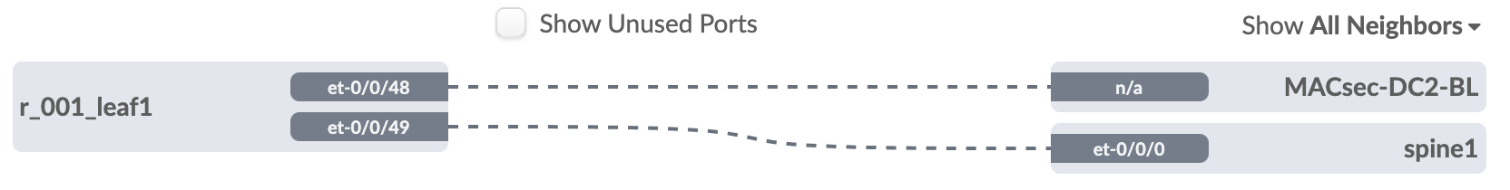

### View from DC2

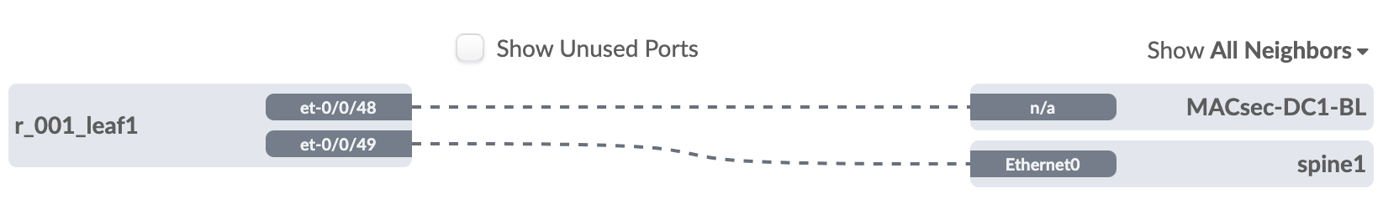

## P2P link IP addressing

The interface IP addresses were manually added as 1.1.1.0/31 on both switches as shown below

### View from DC1

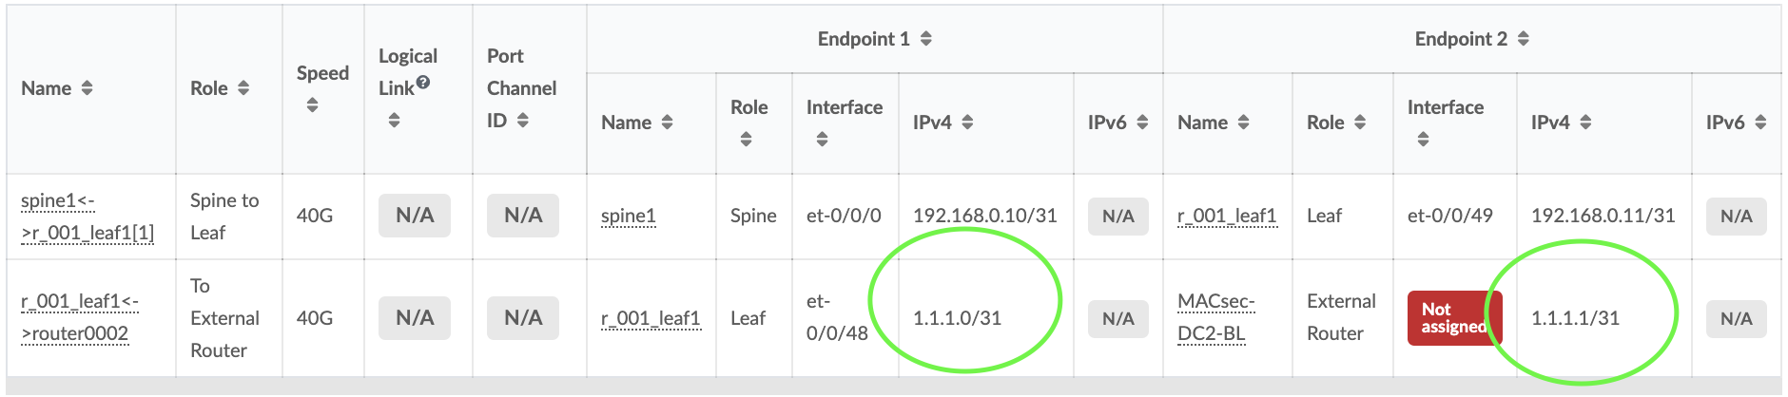

### View from DC2

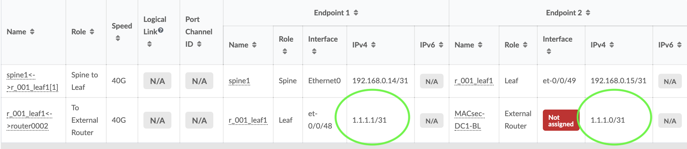

# Configuring MACsec Using CAK

When you enable MACsec using static CAK security mode, a pre-shared key is exchanged between the switches on each end of the point-to-point Ethernet link. The pre-shared key includes a connectivity association name (CKN) and a connectivity association key (CAK). The CKN and CAK are configured by the user in the connectivity association and must match on both ends of the link to initially enable MACsec.

Only when the keys are exchanged and verified will MACSec be enabled on the link. The randomized security key enables and maintains MACsec on the point-to-point link. The key server will continue to periodically create and share a randomly-created security key over the point-to-point link for as long as MACsec is enabled.

You enable MACsec using static CAK security mode by configuring a connectivity association on both ends of the link. All configuration is done within the connectivity association but outside of the secure channel. Two secure channels—one for inbound traffic and one for outbound traffic—are automatically created when using static CAK security mode. The automatically-created secure channels do not have any user-configurable parameters that cannot already be configured in the connectivity association.

## To configure MACsec using static CAK security mode

### Create a connectivity association

**set security macsec connectivity-association DCI-link cipher-suite gcm-aes-xpn-128**

**set security macsec connectivity-association DCI-link security-mode static-cak**

**set security macsec connectivity-association DCI-link include-sci**

**set security macsec connectivity-association DCI-link pre-shared-key ckn 1122334455667788991102132415361748195011621374158617981900F1F2F3**

**set security macsec connectivity-association DCI-link pre-shared-key cak "12345678910121314151617181910FFF"**

**set security macsec interfaces et-0/0/48 connectivity-association DCI-link**

This results in the following configuration which was copy/pasted into a Configlet

*security {*

*macsec {*

*connectivity-association DCI-link {*

*cipher-suite gcm-aes-xpn-128;*

*security-mode static-cak;*

*include-sci;*

*pre-shared-key {*

*ckn 1122334455667788991102132415361748195011621374158617981900F1F2F3;*

*cak "$9$4baDiqmfzn/.mIESrvMDiHkTzp0BIhS/9lKW87NjHkPz369AOIEn6KM8LN-mf5Q69BIEcreRE-Vw2aJFn6/p0hcr8L7s2";*

*}*

*}*

*interfaces {*

*et-0/0/48 {*

*connectivity-association DCI-link;*

*}*

*}*

*}*

*}*

### How to view MACSec working

tzieger@DC2-BL1# **run show security macsec connections**

Interface name: et-0/0/48

CA name: DCI-link

Cipher suite: GCM-AES-XPN-128 Encryption: on

Key server offset: 0 Include SCI: yes

Replay protect: off Replay window: 0

Outbound secure channels

SC Id: 40:8F:9D:49:6E:B5/1

Outgoing packet number: 561

Secure associations

AN: 0 Status: inuse Create time: 01:24:05

Inbound secure channels

SC Id: 40:8F:9D:4A:04:B5/1

Secure associations

AN: 0 Status: inuse Create time: 01:24:05

### How the configlets looks in AIS

